KUBERNETES
Agenda
- Kubernetes Objects and Concepts in GKE
- Common Terms Used in GKE
- Creating a GKE Cluster
- Managing Node Pools
- Autoscaling Configuration
- Accessing Workloads
- Exposing Services
- Deploying PostgreSQL
- Workload Types for DataOps in Kubernetes
Kubernetes Objects and Concepts in GKE:
1. Pod
- In the GKE Console, Pods are shown in Workloads > Pods.
- Created automatically by Deployments, but can also be viewed individually.
- You can inspect logs, resource usage, and live status from the Pod Details page
2. ReplicaSet
- Not directly managed via the UI (created and maintained by Deployments).
- Can be viewed under Workloads > ReplicaSets.
- Automatically ensures the right number of Pods are running.
3. Deployment
- Create via Workloads > Deployments > Create Deployment.
- The wizard allows you to:
  - Set container image
  - Specify replicas
  - Add environment variables
  - Mount volumes
- GKE handles the ReplicaSet and Pod creation under the hood.
4. Namespace
- Access via Kubernetes Engine > Namespaces.
- Used to logically separate resources.
- Useful for organizing different environments like dev, staging, and prod.
5. Labels and Selectors
- Add labels when creating any resource in the UI (e.g., label a Pod with env=prod).
- GKE uses these for grouping, filtering, and targeting resources (like in Services and Network Policies).
6. Services
➤ ClusterIP
- Set in Services & Ingress > Create Service.
- Default option – only accessible within the cluster.
➤ NodePort
- Select this to expose the service at a specific port on all nodes.
- Access via <NodeIP>:<NodePort>, helpful for basic external access.
➤ LoadBalancer
- Automatically provisions a public IP.
- Ideal for internet-facing services.
- Choose this type when creating a Service to expose your app globally.
➤ Ingress Controller & Resource
- Use Services & Ingress > Ingress to define routing.
- First, GKE needs you to install an Ingress Controller (GKE Autopilot includes one).
- Use Ingress to define rules for host/path-based routing to services.
7. Volumes
➤ emptyDir
- Automatically created when a Pod runs, but not visible directly in UI.
- Can be configured via YAML in Advanced > View YAML during Deployment creation.
➤ hostPath
- Not commonly used in GKE (discouraged due to security).
- Best practice is to use Persistent Disks or Cloud Filestore.
➤ Persistent Volume & PVC
- Use Storage > PersistentVolumeClaims to create a PVC.
- GKE supports dynamic provisioning via Storage Classes.
- Attach the PVC in the Deployment UI under Volumes.
8. ConfigMaps and Secrets
➤ ConfigMaps
- Found under Config > ConfigMaps.
- Add key-value pairs (e.g., LOG_LEVEL=debug).
- Can be mounted into Pods as env vars or files.
➤ Secrets
- Found under Config > Secrets.
- Used for storing API keys, passwords, certificates.
- Base64-encoded but should be treated as sensitive.
9. Resource Requests & Limits
- Set during Deployment creation under Advanced Options > Resources.
- Configure:
  - Requests: Minimum guaranteed CPU/Memory
  - Limits: Max allowed usage
- Helps prevent a Pod from hogging node resources.
Common Terms used in GKE:
1. Clusters:
A cluster is the foundation of Kubernetes. It’s like a “computer made of computers” — a group of machines (called nodes) working together to run your applications.
- Think of it like a factory where different workers (nodes) perform tasks based on instructions.
- In GKE, when you create a cluster, Google provisions and manages the underlying machines for you.
- It consists of:
  - Control Plane: The brain of the cluster. It manages scheduling, updates, scaling, etc.
  - Nodes (Worker Nodes): These are the machines (usually virtual machines) where your apps (containers) actually run.
Purpose in GKE: You create a cluster before deploying anything. It provides the environment for everything else.
2. Deployment:
A deployment is like a manager or blueprint for running your application.
- It tells Kubernetes: "Run this container, keep 3 copies running, update them safely if I give you a new version."
- It provides high availability, self-healing, and scaling.
- If one container crashes, the deployment will replace it automatically.
In GKE: You define a deployment in a YAML or JSON file, then apply it to your cluster. It will continuously ensure your app is running as specified.
3. Jobs:
A job is for running one-time or short-lived tasks.
- Think of it like a worker that’s hired to do a task once — e.g., generate a report, back up a database, or process a file.
- Once the job is complete, Kubernetes stops it.
- You can define how many times it should retry if it fails.
In GKE: Jobs are useful for tasks that don’t need to run 24/7, unlike deployments.
4. Containers:
A container is like a self-contained box that includes your application and everything it needs to run — code, libraries, dependencies.
- Think of it like a packaged app that works the same on any machine.
- Containers are much lighter and faster than traditional virtual machines.
- Kubernetes uses a container runtime (like Docker or containerd) to run them.
In GKE: All your workloads (apps, jobs, services) are packaged as containers. Kubernetes schedules them inside Pods (groups of containers), but that's a detail you'll handle later.
Creating a GKE Cluster:
- A GKE Cluster is a managed Kubernetes cluster provided by GCP.
- It consists of:
  - A Control Plane: Managed by Google (handles API server, etcd, scheduler).
  - Node Pools: Groups of VM instances (nodes) running containerized applications.
Key Features:
- Zonal Cluster: All nodes and control planes in a single zone.
- Regional Cluster: Nodes and control plane distributed across multiple zones (better availability).
- Private Cluster: Nodes have internal IPs only; more secure.
Practical:
Step 1: Go to Google Cloud Console → Navigation menu > Kubernetes Engine > Clusters and click "Create".
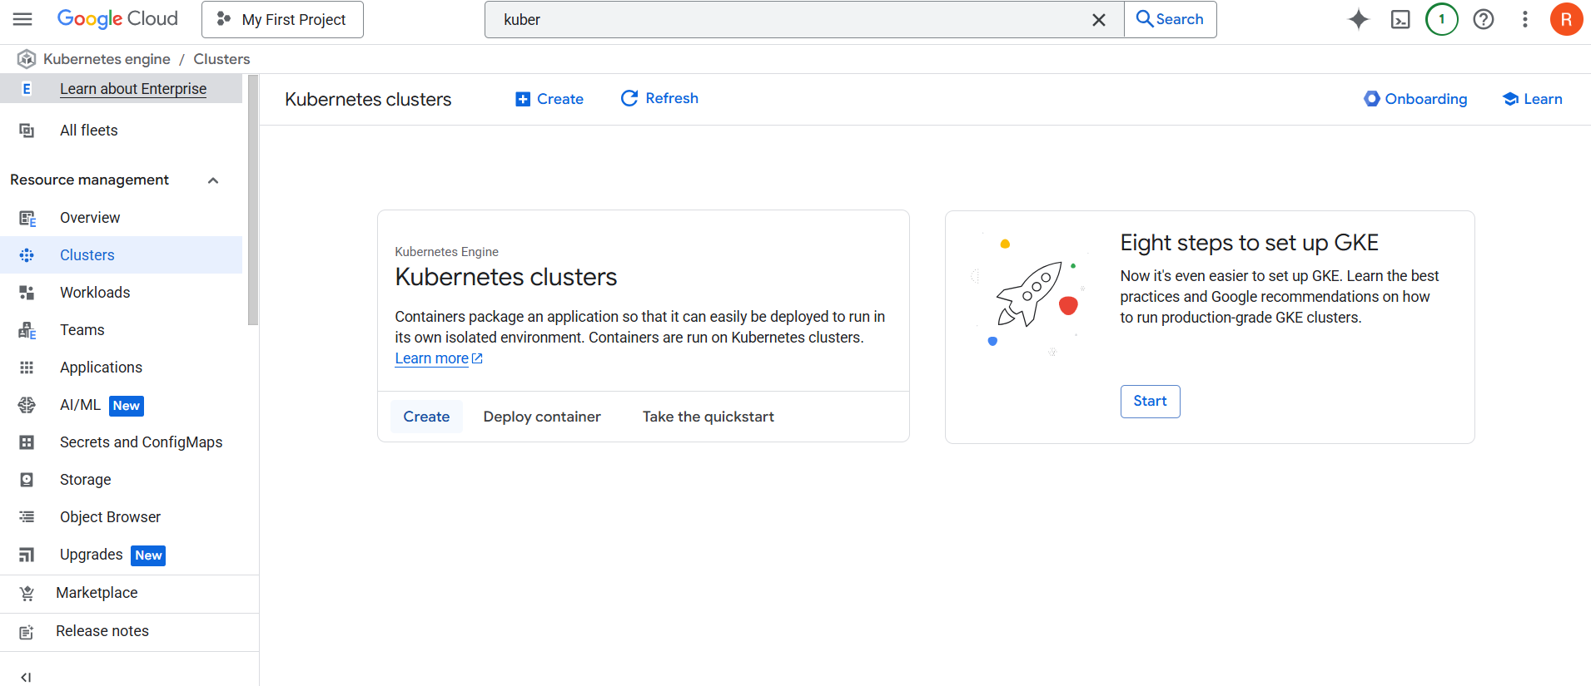
Step 2: Choose Standard cluster and configure:
- Name (e.g., my-gke-cluster)
- Location type: Zonal or Regional
- Zone/Region
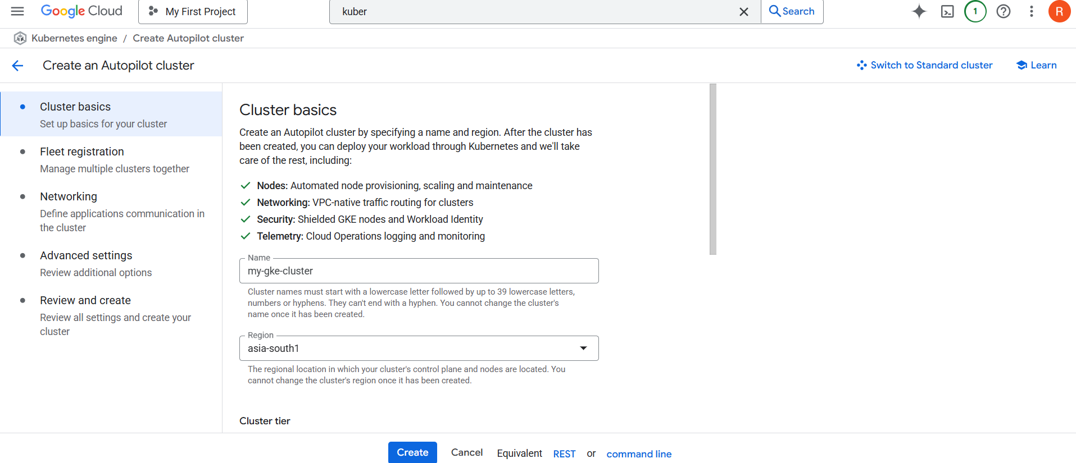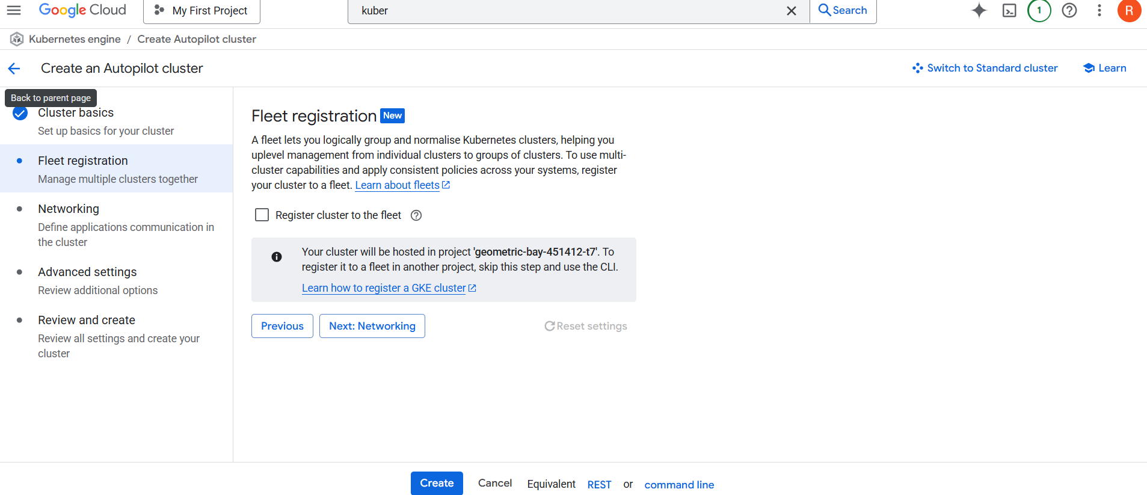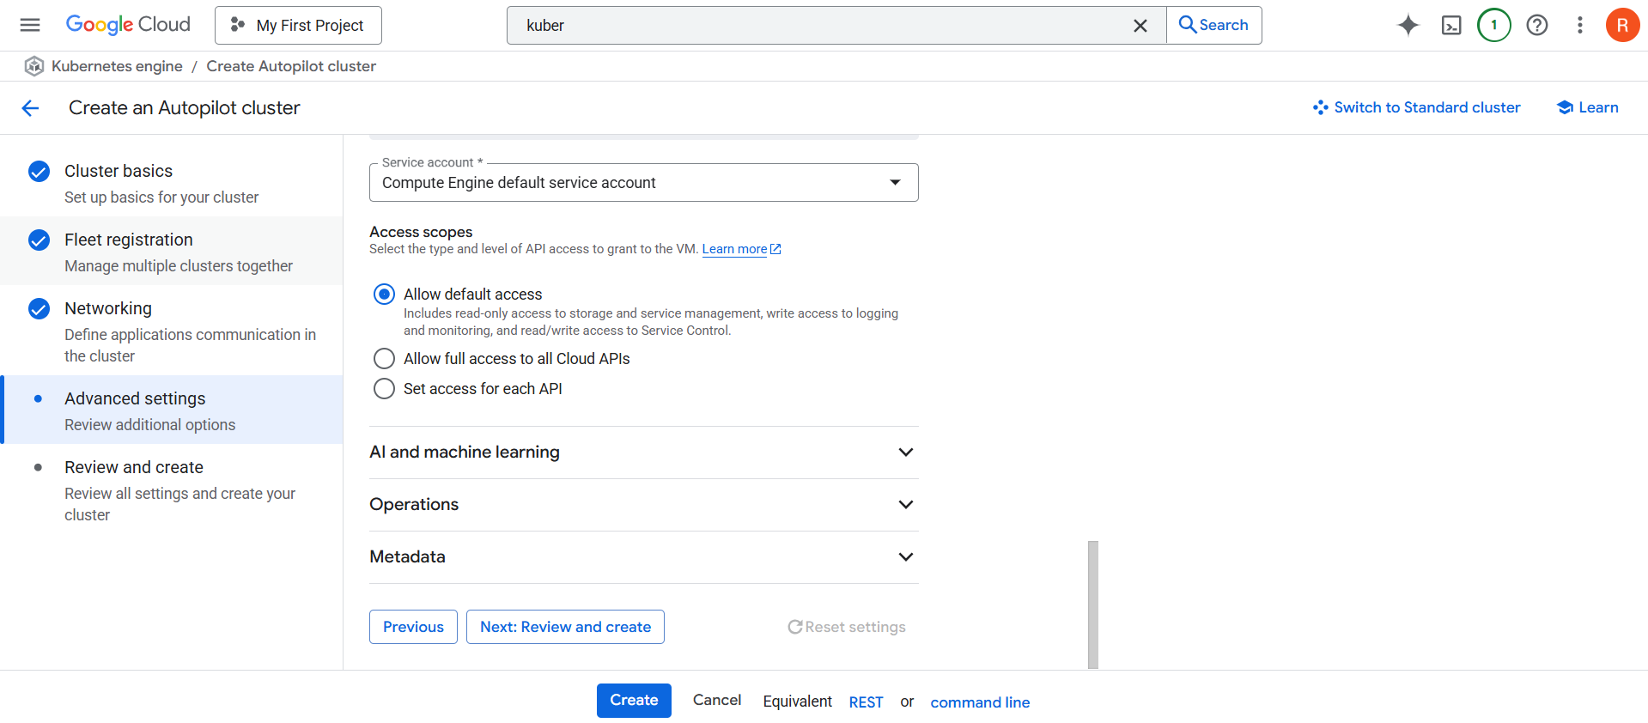
Step 3: Under Node pools, configure:
- Machine type (e.g., e2-medium)
- Number of nodes
Step 4: Optionally enable:
- Auto-upgrade
- Auto-repair
- Shielded nodes
Step 5: Click Create
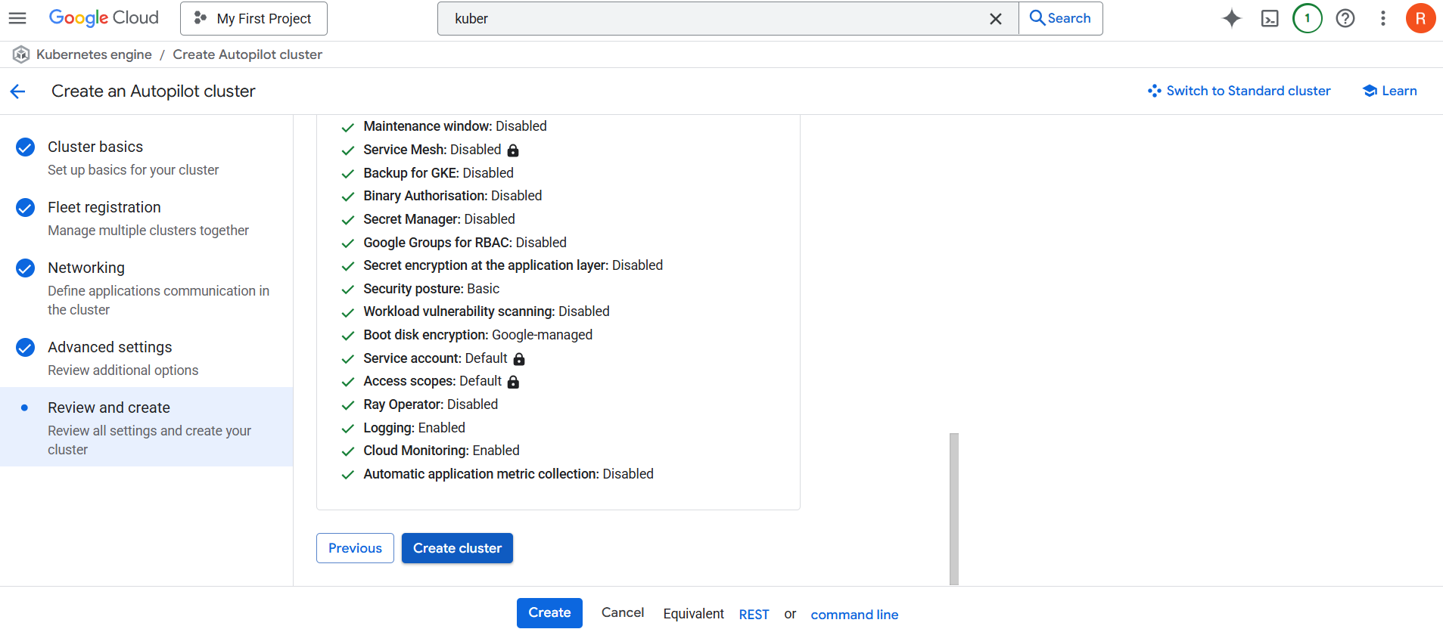
Managing Node Pools:
- A node pool is a group of nodes within a cluster that have the same configuration.
- You can have multiple node pools with different machine types, OS, etc.
Practical:
Step 1: Go to GKE > Clusters > my-gke-cluster
Step 2: Click on the "Nodes" tab
Step 3: Click "Add node pool"
Step 4: Configure:
- Name, Machine type
- Enable Autoscaling if needed
Step 5: Click Create
Autoscaling Configuration:
- Node autoscaling adds/removes nodes based on load.
- Pod autoscaling adjusts the number of pods in a deployment.
A. Node Autoscaling (UI)
Step 1: While creating a node pool, enable:
- Enable autoscaling
- Set min and max node count
Accessing Workloads:
- A workload is a running application, like a deployment, daemonset, etc.
Practical:
Step 1: Go to Kubernetes Engine > Workloads
Step 2: Click "Deploy"
Step 3: Provide container image (e.g., nginx)
- Configure replicas, labels, and environment
- Click Deploy
Exposing Services: NodePort, LoadBalancer, Ingress:
- NodePort: Exposes service on a static port on each node.
- LoadBalancer: Creates a GCP external load balancer.
- Ingress: Manages HTTP(S) access with path and host routing.
Practical:
a. NodePort
- Expose deployment via UI:
  - Choose Service type: NodePort
  - Port range: 30000–32767
b. LoadBalancer
- Choose Service type: LoadBalancer
- External IP will be assigned
- Access via that IP
c. Ingress
- Create a backend service
- Create a Service with ClusterIP
- Create Ingress with routing rules
- UI: GKE > Services & Ingress > Create Ingress
Stateful Workloads & Databases in Kubernetes:
Stateless vs Stateful Workloads:
Stateless Workloads
- Don’t store data between requests.
- Use cases: Frontend apps, APIs, microservices.
- Best with Deployments.
Stateful Workloads
- Store and rely on persistent data.
- Use cases: Databases (PostgreSQL, MongoDB), queues.
- Best with StatefulSets.
Deployment vs StatefulSet:
Feature | Deployment (Stateless) | StatefulSet (Stateful)
Pod Names | Random (pod-xyz) | Stable (db-0, db-1)
Storage | Shared/ephemeral | Dedicated persistent volumes
Start/Stop Order | No guarantees | Ordered, safe shutdown/start
Example Workloads | Web apps | Databases
In GKE Console: Use Workloads → "Create" → Select type.
Storage Classes in GKE:
A StorageClass in GKE defines the type of storage (e.g., SSD, HDD) and the parameters (like provisioner, reclaim policy, etc.) used to dynamically provision PersistentVolumes. It abstracts the underlying storage system and allows Kubernetes to automatically create volumes as needed.
- Example provisioners: kubernetes.io/gce-pd (for Google Cloud Persistent Disks)
- Enables dynamic provisioning of storage
- Supports parameters like disk type, replication, and zone
Go to: GKE → Storage → Storage Classes
StorageClass | Purpose | Ideal For
standard | Balanced PD (default) | General workloads
pd-ssd | SSD-backed Persistent Disks | Databases (fast I/O)
filestore | Shared File Storage (NFS) | File sharing (not DBs)
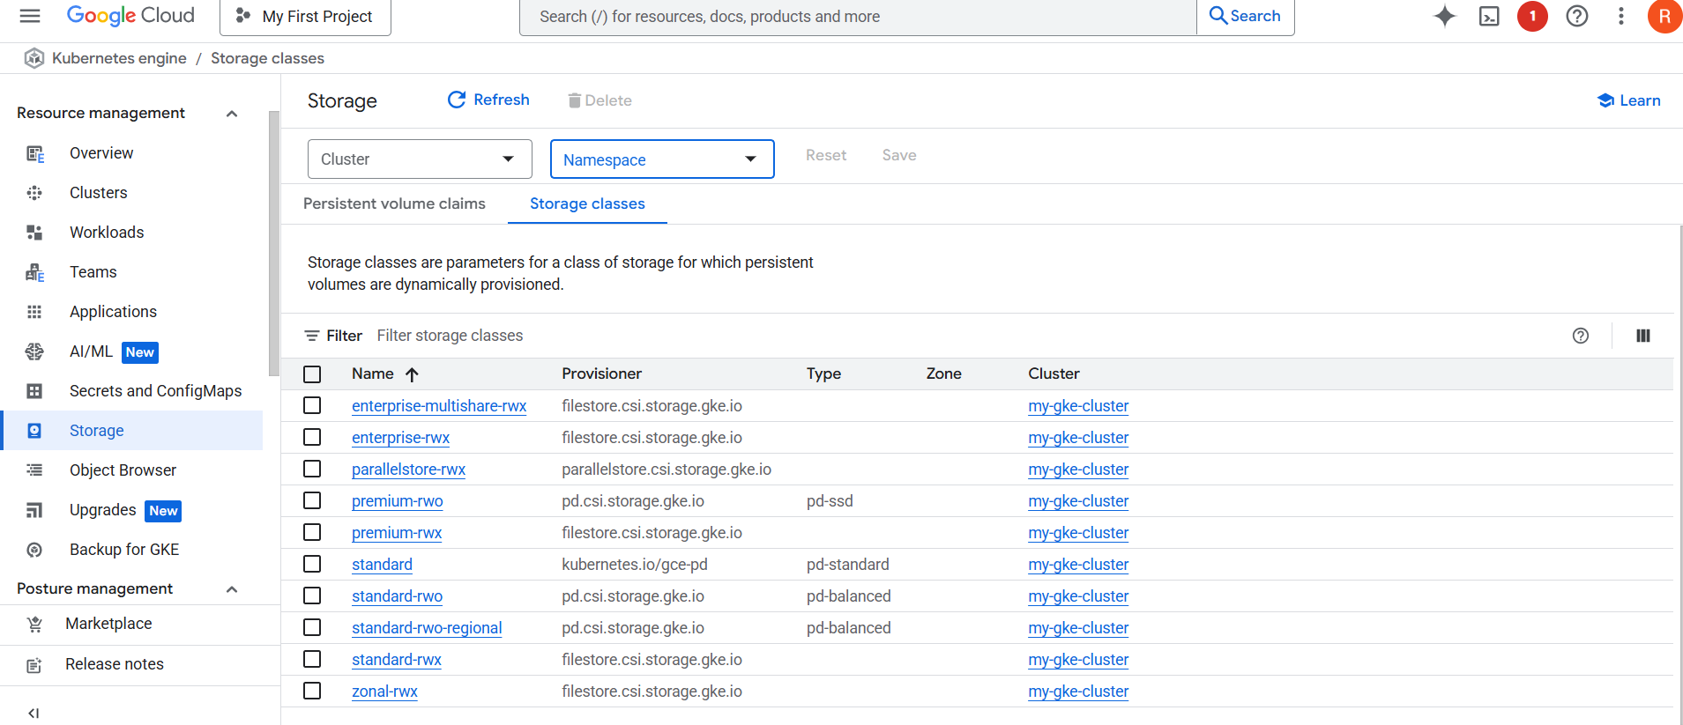
You select a StorageClass when creating PVCs (Persistent Volume Claims).
Persistent Volumes (PV) & PVCs:
A PersistentVolume (PV) is a piece of storage in the cluster that has been provisioned by an administrator or dynamically created using a StorageClass. It is a resource in the cluster, just like CPU or RAM, and provides durable storage for pods.
- Decouples storage from the pod lifecycle
- Can be backed by GCP resources like Persistent Disks
- Managed by Kubernetes and can be reused across pods
Where to Find It:GKE Console → Storage tabKubernetes Dashboard → Persistent Volume Claims
- PV: A provisioned volume in the cluster.
- PVC: A pod’s request for storage.
- StatefulSet: Automatically creates 1 PVC per pod.
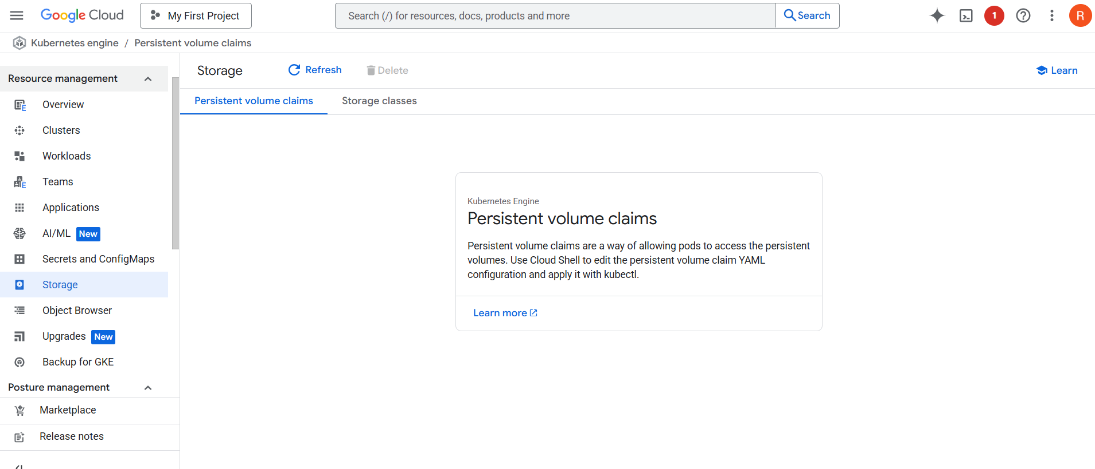
Deploying PostgreSQL:
Step 1: Go to GKE → Workloads → Deploy
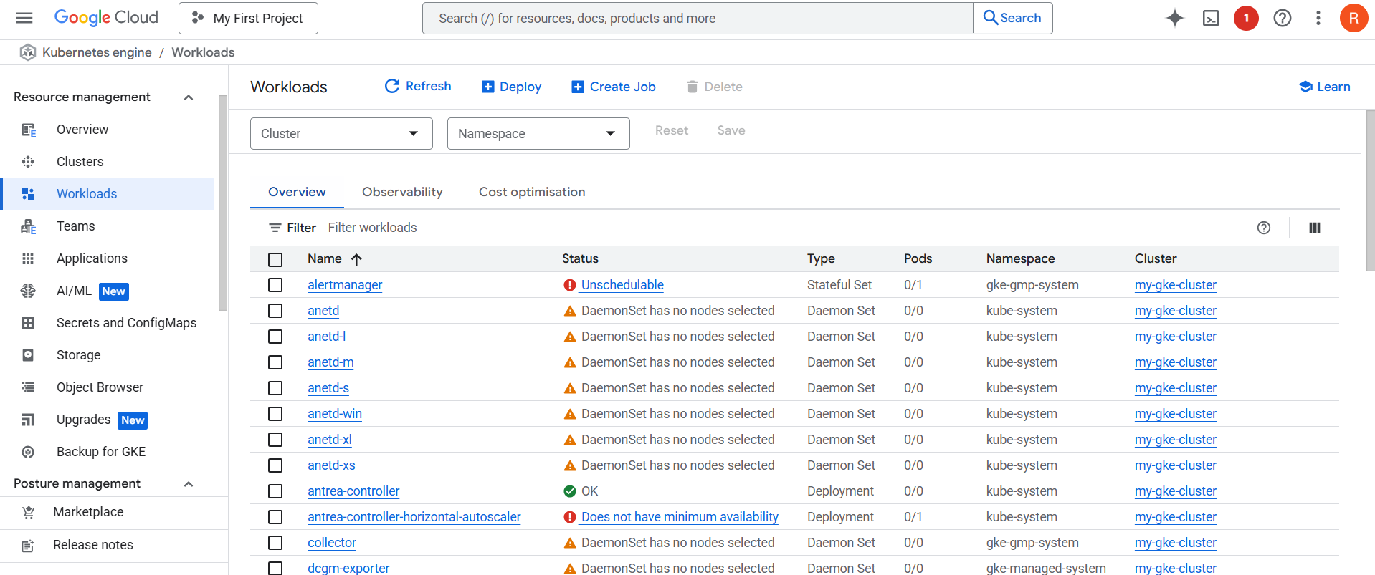
Step 2: Choose Container Image: postgres:14
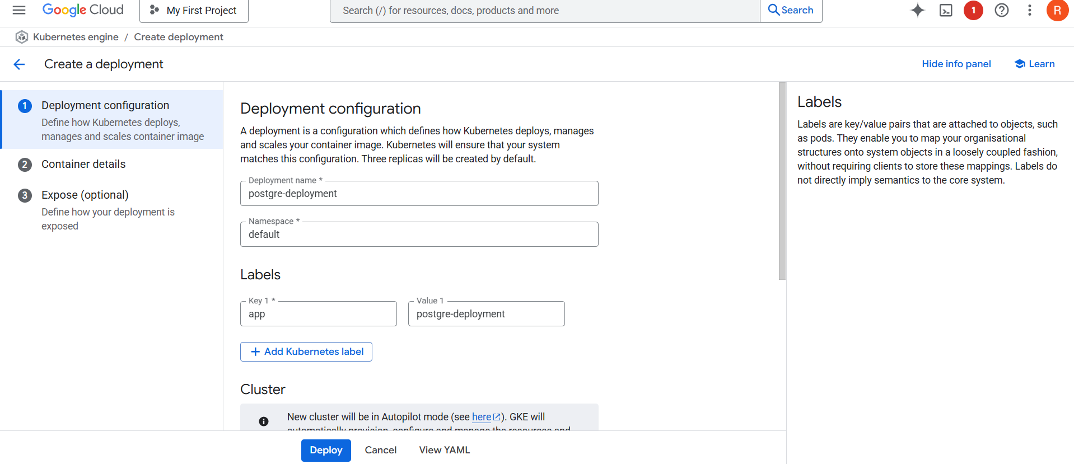
Step 3: Change Advance settings after deployment
- Enable StatefulSet
- Set number of replicas: 1
- Add environment variable: POSTGRES_PASSWORD
Add Volume:
- Volume type: Persistent Disk
- Access Mode: ReadWriteOnce
- Size: e.g., 10Gi
- Choose StorageClass: pd-ssd (if performance needed)
Step 4 : Expose Service if external access is needed
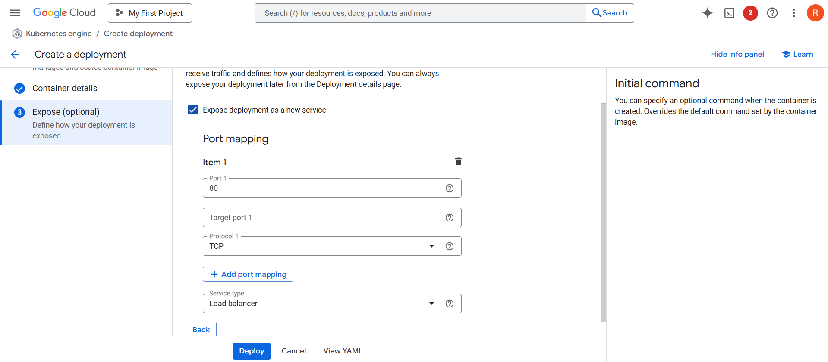
Step 5: Click Deploy.
YAML:
YAML (short for YAML Ain’t Markup Language) is a human-readable data format commonly used in Kubernetes to define configurations like:
- Deployments
- Services
- StatefulSets
- ConfigMaps
- Volumes, etc.
For previous deployment:
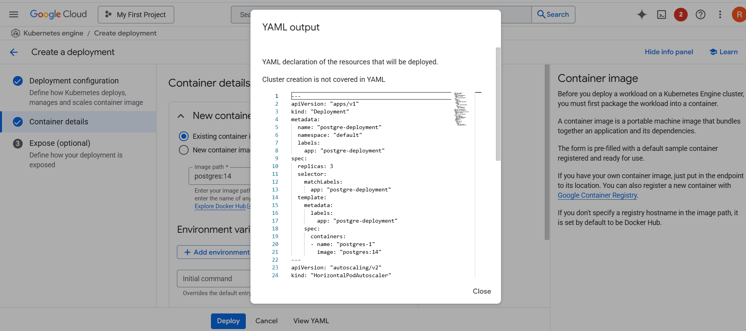
Why YAML in Kubernetes:
- Kubernetes uses YAML files to declare the desired state of your application. You tell Kubernetes:
- Then Kubernetes makes it happen.
Sample YAML (For PostgreSQL Deployment)
apiVersion: apps/v1
kind: StatefulSet
metadata:
name: postgres
spec:
serviceName: "postgres"
replicas: 1
selector:
matchLabels:
app: postgres
template:
metadata:
labels:
app: postgres
spec:
containers:
- name: postgres
image: postgres:14
env:
- name: POSTGRES_PASSWORD
value: "mypassword"
volumeMounts:
- name: postgres-storage
mountPath: /var/lib/postgresql/data
volumeClaimTemplates:
- metadata:
name: postgres-storage
spec:
accessModes: ["ReadWriteOnce"]
resources:
requests:
storage: 10Gi
storageClassName: pd-ssd
Deploying MongoDB ReplicaSet:
Step 1: Go to Workloads → Deploy
Step 2: Image: mongo:6
Step 3: Enable StatefulSet
Step 4: Set replicas: 3 (for replica set)
Step 5: In Container Arguments, add:
- --replSet, rs0, --bind_ip_all
Step 6: Add Persistent Volume:
- Access mode: ReadWriteOnce
- Size: 10Gi
- StorageClass: standard or pd-ssd
Step 7: Click Deploy
After Pods Are Ready:
- Use Cloud Shell or Kubernetes Dashboard Terminal to exec into MongoDB pod.
- Initialize replica set (guided UI not available; CLI needed here).
Scaling Stateful Workloads:
PostgreSQL
- Open Workloads → PostgreSQL
- Click Scale
- Increase CPU, memory, or use read replicas (manual setup)
MongoDB
- Go to Workloads → MongoDB
- Click Scale → Replicas = 5 (example)
- Ensure replication is configured inside MongoDB
Workload Types for DataOps in Kubernetes:
DataOps workflows involve managing data pipelines, processing tools, and automation. Kubernetes offers several workload types tailored for specific data operations. Below are the key types, their purposes, and how to deploy them using Google Cloud's GKE.
1. Deployment:
- A Deployment manages stateless applications like REST APIs or microservices.
- It ensures that a specified number of pods are running and can perform rolling updates.
- Used commonly for data services like API gateways or lightweight data processing apps.
2. CronJob:
- A CronJob runs scheduled tasks such as daily ETL jobs or backups.
- Defined using cron syntax (e.g., 0 2 * * * = 2 AM daily).
- Runs Jobs periodically as per the schedule.
Practical:
Step 1: Go to GKE > Workloads > Create > CronJob.
Step 2: Enter:
- Schedule: 0 1 * * * (for 1 AM daily)
- Image: etl-runner:latest
- Command: ["python", "daily_etl.py"]
Step 3: Add environment variables (e.g., database URL, credentials).
Step 4: Click Deploy.
3. Job:
- A Job runs a task once and ensures it completes successfully.
- Ideal for one-time data migrations, seeding databases, or generating reports.
Practical: Deploy Job
Step 1: Go to GKE > Workloads > Create > Job.
Step 2: Enter:
- Image: python:3.9
- Command: ["python", "load_data.py"]
Step 3: Configure retry limits, timeout, etc.
Step 4: Deploy and monitor job completion status in the UI.

